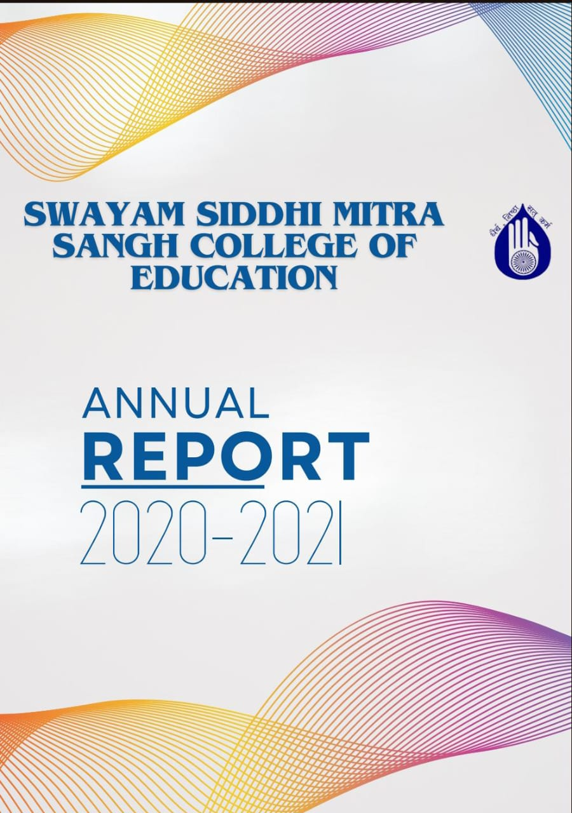

Swayam Siddhi Mitra Sangh College of Education was established in 2004, is the outcome of the sincere and dedicatory efforts of the Trust member under the bold charismatic leadership of CA Shri Suresh Jain and Shri Parag Khandekar. Their vision and love for women empowerment and education made them work hard with the co-operation of the local residents towards the establishment of this college . The college is recognized by the NCTE and affiliated by the SNDT WOMEN’S UNIVERSITY. The College is located in Bhiwandi District Thane Maharashtra state. It reflects the sincerity and devotion of the Teachers towards the institute and commitment of the welfare of education, specially teacher education. The Trust also run the esteemed school by the name of SWAYAM SIDDHI GURUKUL SCHOOL ,which is affiliated to State board. Demographically, this locality is dominated by local agris and kolis, Muslim and migrated population from south and North To be a leader in Educational services Institute provides a Unique learning Experience which enables the students to realize their potential and mould their overall Personality. It also make available equal opportunities and ensure support without prejudice based on class, caste, religion and economic status.
Our Vision
Building a generation of excellent empowered teachers with higher values.
This is achieved by following way
- Use Language that Empowers Teachers. The way we talk to and about teachers makes a big difference in how they feel about themselves and their work
- Provide Frequent, Specific Feedback.
- Encourage Teacher Leadership.
- Support Teacher Professional Development.
- Promote a Positive institutional Culture
MISSION
- To strengthen the weaker sections of Maharashtra state through higher education.
- To empower student teachers by educating them and by creating in them the social, political and cultural awareness.
- To build student teachers confidence to be nation builders. Striving continuously to Provide quality teacher training.
- To carry out teaching and training programs for aspirants as per the norms and standards set by NCTE and state govt.
- To effectively execute various activities under the academic and social responsibility,
Infrastructure and Learning Resources
Infrastructure and Learning Resources The college has adequate infrastructure facilities and resources as per NCTE Norms. The college has built up area of more than 3000.00 sq. m, that consists of Multipurpose Hall, Classrooms, Sports Room , Staff Room, Girl’s Common Room, Canteen, Library-Cum-Reading Room, Laboratories, Principal’s Office, Administrative Office, Store Room, multipurpose hall and play ground. The library is Wi-Fi enabled and well equipped with all the facilities for students and staff members . It consists of wide varieties of text books, reference books of various subjects, magazine and journals. The College puts forth extraordinary attempts to give the furthest down the line innovation to understudies, staying up with the latest with the global world. ICT facilities are accessible to students and staff for exercises connected with instructing educational experience. Throughout the long term college upgrades its equipment, programming and united ICT facilities as indicated by necessities. They also use various ICT resources such as Google and Zoom platform and providing variety of learning experiences to the students. In order to train them in 21st century skills student teachers are encouraged to participate in various activities to gain real life experiences during their internship so that pedagogical skills are developed in them.

B.Ed course is a professional degree course . In this course number of activities are included for the development of the professional skill of the students. To fulfill professional objectives our college organized many activities in the year 2020-2021.The activity Programme included skill development program, orientation program sports ,various day celebration, field trip NGO community work etc

Use of ICT

ICT tool for teaching and learning cover everything from digital infrastructures. It improves concentration ,comprehension and critical thinking. It is stimulates motivation also. Several multimedia presentation were prepared by the students with the help of PowerPoint presentation in different subjects like mathematics ,physics , chemistry, English language ,social science etc.

ICT facilities are available in the computer lab so that in the faculty members can take online classes from college effectively as and when required.

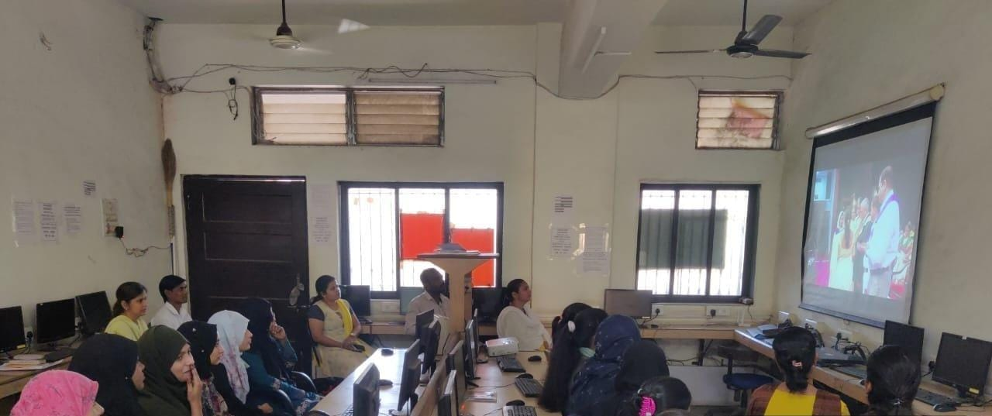

Mentorship

Mentors raises students confidence and problem solving abilities. Along with developing leadership skills, having a mentor to advise and guide student can increase their confidence and help to develop problem solving skills.

Any effective strategy used to train student teacher teachers is by assigning a formal mentor to work one to one with them. The lecturers of the college entrusted the responsibility of mentorship. They Mentor the progress of the students regularly and help in resolving there problems if any

Annual Sports
Annual sports day was held on 26/12/2021-27/12/2021 at the campus of Swayam Siddhi Mitra Sangh college. There was both indoor and outdoor games. We took carom and chess for indoor game. In outdoor games we took dodge ball, khokho ,badminton running etc. Student teacher not only participated as competitors but also learnt how to plan and organized such events in school.

Day celebration
Celebrating different days is an integral part of learning and building a strong cultural belief in a student. Student will remember an important day only if they are told what the occasion signify, making them aware of the world in a more fun way.
Different programmes where planned and organized by the college to inform the student teacher about the cultural importance of special days celebration in school,and also the importance of national integration. Student were participated in those activities. Various days were celebrated during the year 2020-2021 such as Savitribai Phule , Reading Day, Students Day etc

Field trips
Field trips play crucial role in the student learning process. Through field trip student teacher can strengthen their creativity, problem solving skills and critical thinking. The students of S.Y. B.Ed and faculty members had a field visit to Nasik on 5 June 2021. The visit was planned so that the student teacher could learn how to stimulate the senses of the pupils, also they learned to motivate curiosity among the pupils.
Sports were
- Botanical Garden
- Caves
- Planetarium
- Coin Museum
- Water Fall

